The World Language Team takes its
Explorations to MAFLA
By Astrid Allen

When we joined the Content Reading Initiative, we wanted to learn about ways to experiment with more reading in the classroom. Even though many of us had been incorporating reading into the curriculum for years, we still didn’t feel like we were doing our best work. Our students still struggled, and we still had so many questions. When we started our own learnings and experimentations in the summer of 2012, none of us would have told you that in October 2013, we would present at the MAFLA Conference (the Massachusetts Foreign Language Association) to a room full of 60+ people!

As teachers, we are used to speaking in front of a (captive) audience, commanding and shining the spotlight on our content area. But as colleagues and professionals, it turns out we were shy, almost hesitant, to share our own transformations and a-ha moments with regards to reading. In the first year of CRI, we dipped our toe in the Collaboration pond. We shared our work at department meetings and led a Fall Professional Development Day around reading. We created documents that reflected the research we had done, which could help teachers put the research into practice in the classroom. We never believed ourselves to be experts…humbled by how much was still out there to discover about adolescent reading. So, we tried out different ways of sharing and showing methodologies and student data with our department peers and other CRI teams. Slowly, our confidence grew.
When the opportunity to participate in MAFLA appeared serendipitously in my inbox, I couldn’t resist responding [immediately] and writing a conference proposal. I wanted people to know how fantastic my team was! Convincing my team that they were, in fact, fantastic, was the hard part. As we dove into preparations for MAFLA this fall, we were able to see how much we had grown since starting CRI last summer. Over the course of a month, we synthesized our learnings, research, and data to create a multimedia presentation that included student work, interviews with students, videos of teachers in action, and interactive activities, that not only practiced skills but also modeled techniques. We did not just present to our audience; we put them to work.
The presentation began with a video interview series, where we interviewed students about reading… in Spanish. The students were honest, funny, and basically, amazing. As our audience giggled and nodded, we knew our presentation was off to a great start. I continued with an overview of why we started this research and how we articulated it in the classroom, using the “Motivation Triangle” as a framework for our new perspectives on reading. Alisa Conner and Liz Gorman showed teachers our spin on Independent Reading in the Spanish Language classroom, how to determine your purpose when choosing texts for class, and our ideas on cultivating the Habits of Mind to be successful readers in Spanish. The participants then saw Alisa’s students reading independently in the library, highlighting all the work we have started to do with team member and librarian, Shelley Mains. Ric Calleja shared his weekly reading connections with local Spanish-language newspaper, El Planeta, and with a quick video, showed our audience what reading in the classroom looks like. Susan Stark inspired teachers’ artistic side by having them use white boards and markers to present strategies in Interactive Reading. Lastly, Liz led participants in a little reading. The last word belonged to provocative research on vocabulary acquisition in a second language.

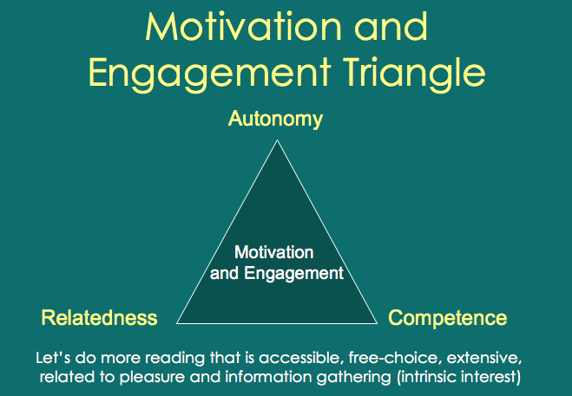

Seventy-five minutes later, we sadly ended our presentation. The energy was palpable. Teachers from across the state wanted more! They wrote notes to us asking for our help and guidance. We can’t wait to share again.

